CSE 3241 Project Part 1

Team 7: Jason Fong, Vivian Comer,

Macray Curran, Cameron Erdman

Introduction

1:

Additional research that we did was looking up what demographic info is made up of. We also researched what medical tools dentists use and who supplies them. The largest part of our research was figuring out how insurance is handled and what is and isn’t covered by insurance.

2:

Two additional features we added were Medical Equipment and Suppliers. Medical Equipment (Entity) has an equipment ID and equipment type. The multi-value equipment has an X-ray machine, Scaler, Forceps, files, dental probes, power tools, and dental mirrors. Suppliers have SupplierName, SupplierAddres, and SupplierPhoneNumber. The reason these entities would be interesting for stakeholders is that dentistry would need to keep track of its equipment supply and where they get their equipment from.

3:

The additional assumptions we made are that patients will always pay with cash, card, or check. Another assumption is that this dentistry gets its medical equipment directly from a supplier.

(E)ERD

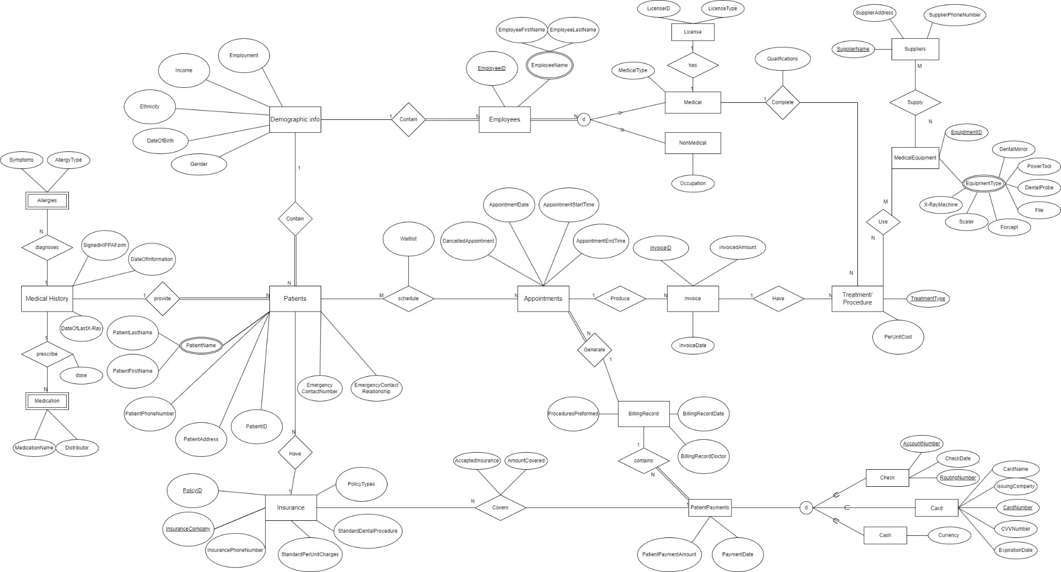

4:

Entities:

(Not including the two additional features above)

1. Insurance
2. DemographicInfo
3. Appointments
4. Patients
5. Employees
6. MedicalHistory
7. Insurance
8. BillingRecord
9. Invoice
10. Treatment/Procedure
11. PatientPayments
12. Check
13. Card
14. Cash
15. Allergies
16. Medication
17. License
18. Medical
19. NonMedical

Attributes:

1. **Insurance:** PolicyID, InsuranceCompany, InsurancePhoneNumber, StandardPerUntCharges, PolicyTypes, StandardDentalProcedure
2. **DemographicInfo:** Employment, Income, Ethnicity, Age, Gender
3. **Appointments:** AppointmentDate, AppointmentStartTime, AppointmentEndTime, CancelledAppointment
4. **Patients:** PatientPaymentMethod, PatientName(PatientLastName, PatientFirstName), PatientPhoneNumber, PatientAddress, PatientID, EmergencyContactNumber, EmergencyContactRelationship
5. **Employees:** EmployeeID, EmployeeName (EmployeeFirstName, EmployeeLastName)
6. **MedicalHistory:** DateOfInformation, SingedHIPPAForm, DateOfLastX-Ray
7. **Insurance:** PolicyID, InsuranceCompany, InsurancePhoneNumber, StandardPerUnitCharges, StandardDentalProcedure, PolicyTypes
8. **BillingRecord:** ProceduresPreformed, BillingRecordDate, BillingRecordDoctor,
9. **Invoice:** InvoiceID, InvoicedAmount, InvoiceDate
10. **Treatment/Procedure:** TreatmentType, PerUnitCost
11. **PatientPayments:** PatientPaymentAmount, PaymentDate
12. **Check:** CheckDate, RoutingNumber, AccountNumber
13. **Card:** CardName, IssuingCompany, CardNumber, CVVNumber, ExpirationDate
14. **Cash:** Currency
15. **Allergies:** Symptoms, AllergyType
16. **Medication**: MedicationName. Distributor
17. **License**: LicenseID, LicenseType
18. **Medical**: MedicalType
19. **NonMedical**: Occupation

5:

1. Patients contain demographic info
2. Employees contain Demographic info
3. Patients provide Medical History
4. MedicalHistory diagnoses Allergies
5. MedicalHistory prescribes Medication
6. Patients have insurance
7. Patients schedule appointments
8. Appointments generate BillingRecord
9. Appointments produce Invoice
10. Invoices have treatments or procedures
11. Employees-Medical complete treatments or procedures
12. Treatments or procedures use medical equipment
13. Suppliers supply medical equipment
14. BillingRecord contains patient payments
15. Insurance covers patient payments

6:

Informal Queries/Reports:

1. When billing an employee wants to see the patient's insurance coverage.
2. An employee wants to search for a patient’s medical history
3. An employee wants to search for the treatments they have to give on a date
4. A patient wants to see their past appointments and treatments

7:

| Patients | | | | |
| --- | --- | --- | --- | --- |
| PatientID | PatientLastName | PatientFirstName | PatientName | PatientPhoneNumber |
| 1 | Kline | Jim | Jim Kline | 123-456-7890 |
| 2 | Sarja | Kay | Kay Sarja | 123-456-7891 |
| 3 | Linn | Sarah | Sarah Linn | 123-456-7894 |
| 4 | Hens | Bill | Bill Hens | 123-456-2141 |
| 5 | Mar | Tim | Tim Mar | 421-325-1345 |

| Emergency Contact | |
| --- | --- |
| Number | Relationship |
| 612-421-6534 | Father |
| 611-512-1236 | Mother |
| 517-120-5305 | Father |
| 614-064-9535 | Uncle |
| 401-454-9963 | Mother |

| Medications | |
| --- | --- |
| Distributor | Medication Name |
|  | None |
| Henry Schein | Advil |
|  | None |
|  | None |
| McKesson | Insulin |

| Allergies | |
| --- | --- |
| Symptoms | Allergy Type |
| Running Nose | Tree Nuts |
|  | None |
| coughing | Tylenol |
| Swollen Eyes | Sunflower |
|  | None |

|  | Medical History |  |
| --- | --- | --- |
| DateOfInformation | SignedHIPPAForm | DateOfLastX-Ray |
| 9/15/2022 | TRUE | 9/15/2022 |
| 8/12/2022 | TRUE | 8/12/2022 |
| 7/24/2022 | TRUE | 7/24/2022 |
| 1/21/2022 | FALSE | 1/13/2022 |
| 4/1/2022 | TRUE | 7/6/2022 |

| Insurance | | | | | |
| --- | --- | --- | --- | --- | --- |
| PolicyID | InsuranceCompany | InsurancePhoneNumber | StandardPerUnitCharges | StandardDentalProcedure | PolicyTypes |
| 1942 | BlueCross | 132-142-5421 | 200 | 100 | Full |
| 1242 | Athena | 123-111-1232 | 600 | 250 | Partial |
| 12341 | Athena | 123-111-1232 | 900 | 470 | Partial |
| 750 | Aflec | 132-314-1234 | 800 | 900 | Full |
| 68754 | Shield | 536-341-1456 | 349 | 700 | Partial |

| Demographic Info | | | | |
| --- | --- | --- | --- | --- |
| Employment | Income | Ethnicity | DateOfBirth | Gender |
| F | 0 | Polish | 8/2/2001 | M |
| T | 50000 | Caucasian | 10/12/1999 | F |
| F | 0 | Azeri | 2/2/2004 | M |
| T | 60000 | Irish | 1/9/1992 | M |
| T | 38000 | Haitian | 2/2/2002 | M |

| Employees | | | | | |
| --- | --- | --- | --- | --- | --- |
| Medical | Non_Medical | EmployeeID | EmployeeFirstName | EmployeeLastName | EmployeeName |
| FALSE | TRUE | 42314 | Riley | Kine | Riley Kine |
| TRUE | FALSE | 32989 | Caitie | Rizzo | Caitie Rizzo |
| FALSE | TRUE | 30051 | Michelle | Houston | Michelle Houston |
| TRUE | FALSE | 142521 | Fin | Flannigan | Fin Flannigan |
| TRUE | FALSE | 42525 | Jan | Jannis | Jan Jannis |
| TRUE | FALSE | 123413 | Tim | Tam | Tim Tam |

| Appointments | | | |
| --- | --- | --- | --- |
| CancelledAppointment | AppointmentDate | AppointmentStartTime | AppointmentEndTime |
| F | 9/14/2022 | 900 | 1000 |
| F | 9/12/2022 | 400 | 500 |
| F | 9/11/2022 | 1700 | 1800 |
| F | 8/22/2022 | 1230 | 130 |
| F | 9/1/2022 | 130 | 230 |

| Invoice | | |
| --- | --- | --- |
| InvoiceID | InvoicedAmount | InvoiceDate |
| 12340 | 120 | 9/21/2022 |
| 42051 | 50 | 9/19/2022 |
| 14529 | 120 | 9/18/2022 |
| 92895 | 250 | 8/29/2022 |
| 24913 | 1200 | 9/8/2022 |

| Billing Record | | |
| --- | --- | --- |
| ProceduresPreformed | BillingRecordDate | BillingRecordDoctor |
| XrayCheckup | 9/14/2022 | Caitie Rizzo |
| Checkup | 9/12/2022 | Caitie Rizzo |
| XrayCheckup | 9/11/2022 | Jan Janis |
| Cavity | 8/22/2022 | Fin Flannigan |
| RootCanal | 9/1/2022 | Tim Tam |

| Patient Payments | |
| --- | --- |
| PatientPaymentAmount | PaymentDate |
| 120 | 9/14/2022 |
| 50 | 9/12/2022 |
| 120 | 9/11/2022 |
| 250 | 8/22/2022 |
| 1200 | 9/1/2022 |

| Check | | Card |  |  |  |  | Cash |
| --- | --- | --- | --- | --- | --- | --- | --- |
| CheckDate | RoutingNumber | CardName | IssuingCompany | CardNumber | CVVNumber | ExpirationDate | Currency |
| 9/14/2022 | 1.23921E+11 |  |  |  |  |  |  |
|  |  | Kay Sarja | Discover | 1.39429E+11 | 723 | 12/12/2028 |  |
| 9/11/2022 | 13984209815 |  |  |  |  |  |  |
|  |  | Bill Hens | Chase | 1.34825E+11 | 889 | 1/23/2027 |  |
|  |  |  |  |  |  |  | USD |

| Insurance Cover | |
| --- | --- |
| Accepted | Amount_Covered |
| FALSE |  |
| FALSE |  |
| FALSE |  |
| FALSE |  |
| TRUE | 700 |

| Treatment/Procedure | |
| --- | --- |
| TreatmentType | PerUnitCost |
| XrayCheckup | 120 |
| Checkup | 50 |
| Root Canal | 1200 |
| Cavity | 250 |
| XrayCheckup | 120 |
| Checkup | 50 |
| XrayCheckup | 120 |
| Cavity | 250 |
| RootCanal | 1200 |
| Cavity | 50 |

| Medical Equipment | | | | | | | |
| --- | --- | --- | --- | --- | --- | --- | --- |
| EquipmentID | X-RayMachine | Scaler | Forcept | File | DentalProbe | PowerTool | DentalMirror |
| 1;2;5;7 | TRUE | TRUE | FALSE | FALSE | TRUE | FALSE | TRUE |
| 2;5;7 | FALSE | TRUE | FALSE | FALSE | TRUE | FALSE | TRUE |
| 2;3;4;5;6;7 | FALSE | TRUE | TRUE | TRUE | TRUE | TRUE | TRUE |
| 2;3;4;5;6;7 | FALSE | TRUE | TRUE | TRUE | TRUE | TRUE | TRUE |
| 1;2;5;7 | TRUE | TRUE | FALSE | FALSE | TRUE | FALSE | TRUE |
| 2;5;7 | FALSE | TRUE | FALSE | FALSE | TRUE | FALSE | TRUE |
| 1;2;5;6 | TRUE | TRUE | FALSE | FALSE | TRUE | FALSE | TRUE |
| 2;3;4;5;6;7 | FALSE | TRUE | TRUE | TRUE | TRUE | TRUE | TRUE |
| 2;3;4;5;6;7 | FALSE | TRUE | TRUE | TRUE | TRUE | TRUE | TRUE |
| 2;3;4;5;6;7 | FALSE | TRUE | TRUE | TRUE | TRUE | TRUE | TRUE |

| Suppliers | | |
| --- | --- | --- |
| SupplierName | SupplierAddress | SupplierPhoneNumber |
| Azdent | 1239 8th Way | 112-249-9928 |
| Net32 | 1248 12th Ave | 921-0092-8131 |
| Azdent | 1239 8th Way | 112-249-9928 |
| Azdent | 1239 8th Way | 112-249-9928 |
| Benco | 8429 1st St | 718-284-9428 |
| Azdent | 1239 8th Way | 112-249-9928 |
| Benco | 8429 1st St | 718-284-9428 |
| Azdent | 1239 8th Way | 112-249-9928 |
| Net32 | 1248 12th Ave | 921-0092-8131 |
| Net32 | 1248 12th Ave | 921-0092-8131 |

| Medical Jobs | NonMedical |
| --- | --- |
| Dentist | Front Line Desk |
| Dentist Assistant | Software Engineers |
| Hygienist | Customer Support |
| Anesthetics |  |
|  |  |

Cross Check 1:

A new appointment record will require an invoice to be produced with treatment/procedure details, employees active, and generate a billing record. New patients would also have to input their insurance details, medical history, and personal attributes.

To correctly generate an appointment you would also need the following attributes: treatment type, equipment ID, Supplier Name, Employee ID, and Invoice ID. While new patients would also need an Insurance Company, Insurance ID, and Allergies.

Our database will store multiple values for allergies and medications and make them mandatory so the doctor is aware of them when the appointment is booked.

Cross Check 2:

It satisfies all minimum requirements

Cross Check 3:

EERD approach and necessary generalizations are utilized.

12:

Macray Curran: ER Diagram/Report

Vivian Comer: ER Diagram/Report

Jason Fong: ER Diagram/Spreadsheet

Cameron Erdman: Spreadsheet/Report

The way our team has functioned so far is that we would get together to work in big chunks, and then iron out small details on our own afterward. I think this approach has been pretty healthy and non-stressful so far and will keep being a good way to manage our time.